Source https://bevacationtravels.com/product/maldives-sandbank-visit-snorkeling-and-dolphin-watching-cruise/
__________________________________________________________

Maldives Ocean Escape: Sandbank Bliss, Snorkeling & Dolphin Safari
__________________________________________________________
★★★★★ 4.7/5 20 reviews

Add to wishlist ♡

__________________________________________________________

5–5.5 hours | €90 per person

🏕  Image | 🏕  Image | 🏕  Image | 🏕  Image | 🏕  Image | 🏕  Image

__________________________________________________________
About This Tour
Spend an unforgettable half-day exploring the tropical wonders of the Maldives. This all-in-one island adventure combines pristine sandbanks, vibrant coral reefs, and the thrill of dolphin watching in open waters. With snorkeling gear, beach time, canoeing opportunities, and a picnic lunch included, you can simply relax and enjoy paradise without worrying about planning the details.
Perfect for travelers with limited time who still want the full Maldivian experience.
__________________________________________________________
What’s Waiting for You
- Duration: 5–5.5 hours
- Group Size: Up to 25 travelers
- Accommodation: Not included (day tour)
- Languages Available: English
- Private Tour: No (shared experience)
- Transportation: Boat excursion from Hulhumale
- Season: Year-round
- Meeting Point: Hulhumale Excursion Jetty (Lakudi Jetty)
__________________________________________________________

Check Dates & Availability

Select participants: (Age 99 and younger) - 1 +

Choose date:
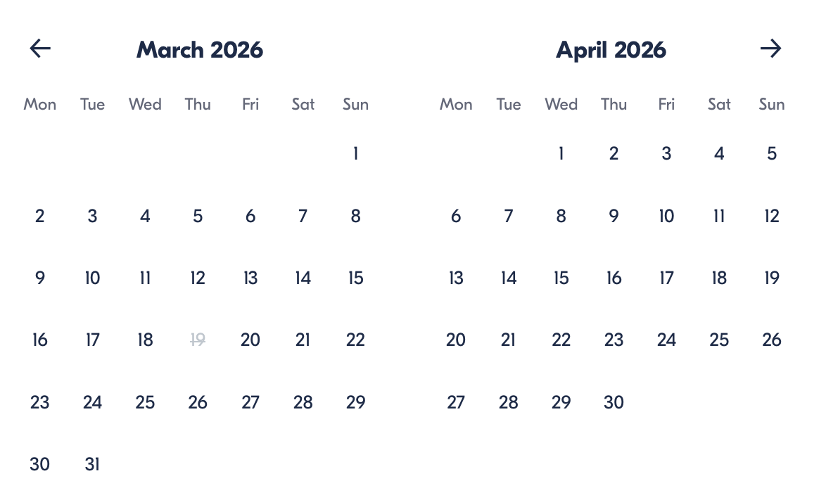

Check Availability

opens:

Participants: 1 March 16, 2026

Maldives Ocean Escape: Sandbank Bliss, Snorkeling & Dolphin Safari

- Duration: 5–5.5 hours
- Offered in: English
- Starts at: 9:00 AM

Price breakdown: 1 Participant x €90

Total: €90

The total price includes all taxes and fees.

Add to cart Book now

__________________________________________________________
Tour Features
- Visit a stunning natural sandbank surrounded by turquoise waters
- Guided snorkeling at vibrant reef locations with rays and tropical fish
- Dolphin watching cruise through a known dolphin channel
- Snorkeling equipment, life jackets, and safety gear included
- Picnic lunch served during the excursion
- Canoeing and beach time for relaxation and photos
- Beach towel and bottled water provided
- Complimentary hotel pickup from Hulhumale
__________________________________________________________
Detailed Itinerary

Morning – Departure from Hulhumale
Meet your guide at Hulhumale Excursion Jetty for a short briefing before boarding your boat. Guests staying in Hulhumale may use the complimentary hotel pickup service. The boat departs around 9:30 AM.

Sandbank Experience
Cruise toward a breathtaking sandbank near Himmafushi Island. Relax on powder-white sands, swim in crystal-clear lagoons, take photos, or simply enjoy the peaceful surroundings. This is your perfect Maldives postcard moment.

Snorkeling Adventure
Head to a carefully selected reef site such as Kanduoih-giri. Equipped with snorkeling gear and guided assistance, explore vibrant coral formations and encounter tropical fish, stingrays, and possibly moray eels. Locations may vary depending on sea conditions to ensure the best experience.

Dolphin Watching Cruise
Continue to a dolphin channel known for frequent sightings. With a bit of luck, you may witness pods of dolphins swimming and leaping beside the boat — a magical highlight of the day.

Return to Hulhumale
After a relaxing and activity-filled excursion, cruise back to Hulhumale with unforgettable ocean memories.
__________________________________________________________
Included in Price
- Boat excursion
- English-speaking tour guide
- Snorkeling equipment
- Life jackets and safety gear
- Picnic lunch
- Beach towel
- Bottled water
- Shower and changing room facilities
- Local island visit and souvenir stop
- Complimentary pickup from Hulhumale hotels
- All taxes and service fees
__________________________________________________________
Not Included
- Pickup from Male City, the airport, or private resorts
- Alcoholic beverages
- GoPro or drone photography services
- Personal expenses and gratuities
- Private transport
__________________________________________________________
Who Should Avoid This Tour
- Wheelchair users (not accessible)
- Travelers uncomfortable with boat travel
- Guests with severe seasickness
- Individuals unable to swim (basic water confidence recommended)
- Travelers requiring private or luxury yacht service
__________________________________________________________
Important Trip Info
- Meeting point: Hulhumale Excursion Jetty (Lakudi Jetty) between 9:00 and 9:30 AM
- Boat departure at approximately 9:30 AM
- Maximum group size: 25 participants
- Tour is weather-dependent; rescheduling or a full refund is available if canceled due to conditions
- Infants must sit on laps
- Service animals are permitted
- Snorkeling locations may change based on water visibility and safety
- Dolphin sightings cannot be guaranteed (wildlife experience)
- Most travelers can participate
__________________________________________________________

Cancellation Policy
For 5 or Fewer Participants:
- More than 2 weeks before arrival: 40% Credit / 60% Refund
- Less than 2 weeks before arrival: 50% Credit / 50% Refund
- Less than 72 hours before arrival: No refund or credit
For 6 or More Participants:
- More than 4 weeks before arrival: 40% Credit / 60% Refund
- Less than 4 weeks before arrival: 80% Credit / 20% Refund
- Less than 2 weeks before arrival: No refund or credit
Weather-Related Cancellations: Fully refunded if conditions prevent safe operation.
Refund Processing: Within 15 days after tour completion.
__________________________________________________________
What Our Clients Are Saying

Overall rating  4.7/5  ★★★★★  Based on 20 reviews | Review summary  Guide 4.5/5  Transportation 4.6/5  Service 4.7/5  Organisation 4.5/5

Filter  - All traveller types  - Couples  - Group of friends  - Families  By star rating  - All star ratings  - 5 stars  - 4 stars  - 3 stars  - 2 stars  - 1 star | Search reviews (e.g., guide)  Sort by:  - Top picks  - Latest reviews  - Best ratings  - Lowest ratings
__________________________________________________________
★★★★★ Emily W. — United Kingdom
Seeing dolphins swimming alongside our boat was magical. The sandbank felt like paradise.
★★★★☆ Sarah S. — United Kingdom
Snorkeling was amazing. We didn’t see many dolphins, but overall great experience.
★★★★★ Daniel R. — United States
An incredible ocean adventure! The snorkeling spots were full of colorful fish, and the sandbank stop was breathtaking. The guides were friendly and made everything easy and fun.
★★★★★ Sofia M. — Spain
Absolutely loved this tour. The water was crystal clear, the picnic was delicious, and seeing dolphins swimming beside the boat was unforgettable.
★★★★☆ Lucas T. — France
Great experience overall. The snorkeling was the highlight for me, and the crew was very professional. The sandbank was beautiful, but we wished we had more time there.
★★★★★ Aisha K. — UAE
Perfect half-day trip! Everything was well organised, from pickup to return. The snorkeling gear was clean, and the guide explained everything clearly.
See more reviews
__________________________________________________________

Meta tags

Page - Maldives Ocean Escape: Sandbank Bliss, Snorkeling & Dolphin Safari

Title: Maldives Ocean Escape: Sandbank Bliss, Snorkeling & Dolphin Safari | Travellio Global

Description: Explore the Maldives on a half-day sandbank, snorkeling, and dolphin watching adventure. Perfect for travelers seeking marine wildlife and tropical paradise experiences.

H1 - Maldives Ocean Escape: Sandbank Bliss, Snorkeling & Dolphin Safari
__________________________________________________________

